There is a Buzz at LCHS – The ‘Bee-Wise’ Project !
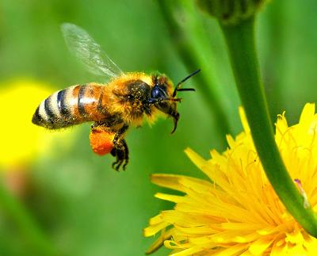
We are excited to share that LCHS’s EcoVision Club (a club for student leaders interested in environmental change) and LCHS’s agriculture classes will be studying honeybees. As part of the their project, EcoVision would like to place two small honey bee hives on the roof of the school. The hives will only be accessed under supervision, through a secure door next to the teachers photocopy room. Only those students and staff working on the project will have permission to access the hives.
Staff and students working on this project are currently working with a local bee expert, and Crestomere School (School which already have bees) to learn about the complicated life of bees and how they make honey. Handling of the bees or visiting the hives will only happen under the supervision of our bee expert. This is an exciting project and if the group is successful at managing the hives, we will have some tasty honey to share in 2017.
Questions
Are people in danger of being stung by the bees? Because the hives will be located on the roof of the school, there should be no significant risk to our students or residents of Lacombe. Bees have frequently buzzed around the outdoor LCHS gardens in the spring and summer for the past three years and we have never had a issue. In addition, through our agriculture class and community workshops we will educate students and interested community members about how to handle bees.
How long will the hives be there? Hopefully as long as they produce honey for us.
What if a student has an allergy/reaction to bee stings? Please inform the LCHS as soon as possible so we are aware and can be prepared. Even without the hives, we should be aware of any students who might be at risk.
LCHS Staff and students are very excited about the possibilities that might arise from our Honey Bee Hive project. With the support of the community, we hope to produce enough honey to sell as a fundraiser to support our Dow community garden and build our agricultural opportunities.
If you have any further questions about this project, please contact Mr. Schultz at by phone at 403-782-6615 or by email at steven.schultz@wolfcreek.ab.ca.

Bee Project Update

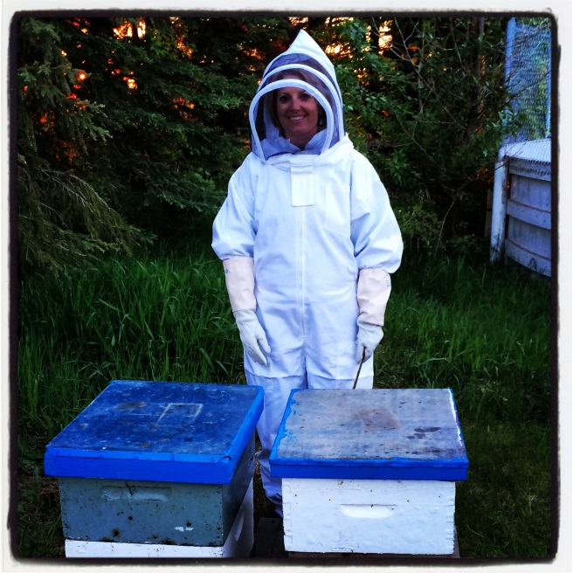
Exciting News!
We are closer to having bees at LCHS. Jayson Lovell of our school board has agreed to look at our proposal after the following three questions have been answered.
1. Do you, or Brad Buss (Wolfcreek’s maintenance supervisor), anticipate any issues with having the bee hives on the roof when it comes to contractors possibly working up there? ANSWER: We are working with Brad on this issue and have suggested that we move the bee hives to another location on the roof of the school when this happens.
2. Have you consulted with the City of Lacombe to determine any restrictions or requirements from the City in relation to the ability to have a bee farm in the City?
ANSWER: We are currently seeking permission from the City of Lacombe Manager to become beekeepers as in accordance to By Law #35 section 3 & 4, which is posted below.
3. Unless authorized and licensed under Bylaw 419, No person or body corporate shall be permitted to own, keep or harbour livestock, wild animals, poultry or bees, within any portion of the town of Lacombe or its corporate boundaries without the exclusive written permission of the Town Manager. (06/27/2016)
4. Any Inspector may seize and impound any livestock, wild animals, poultry or bees, within any portion of the Town of Lacombe or its corporate boundaries, if the livestock, wild animals, poultry or bees are being kept without the written permission of the Town Manager.
3. Your letter indicates "consultations" will take place. Can you provide additional details like when, who will be involved, etc.
ANSWER: Consultations will take place at LCHS in September. Parents. Lacombe citizens and interested stack holders will be invited to an information session in September. Stack holders will be invited to this session through a newsletter, an advertisement in the local newspaper, a post on LCHS website and any other notification medium recommended.

This is an exciting opportunity for our school to be involved in something great. Staff and students are enthusiastic and motivated to do whatever we can to make this project a huge success. We also extend a warm welcome to any community member who might have knowledge and experience with bees to come join our team. Let’s come together and support our students in a learning project that is real, meaningful, and highly important to our earth. Please contact Steven Schultz at 403-782-9839 or steven.schultz@wolfcreek.ab.ca if you require additional information.

