There is a Buzz at LCHS – The ‘Bee-Wise’ Project !

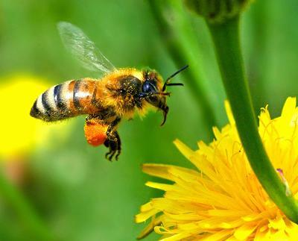
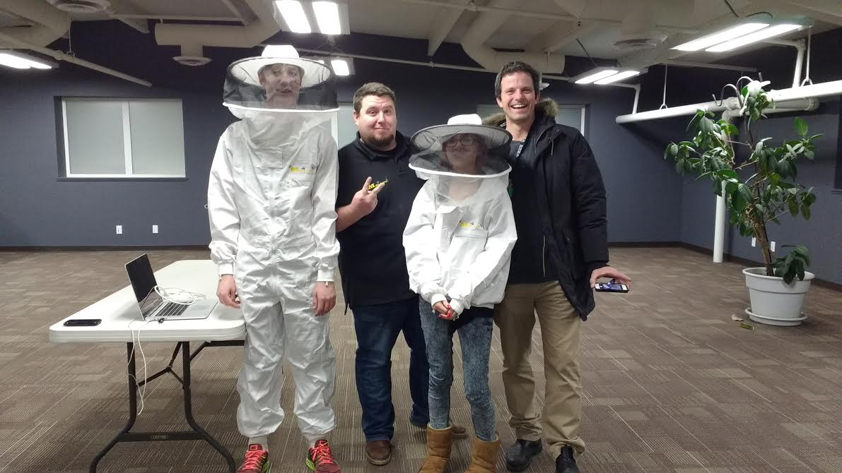
We are excited to share that LCHS’s EcoVision Club (a club for student leaders interested in environmental change) and LCHS’s agriculture classes are studying honeybees. As part of the their project, EcoVision has placed two small honey bee hives in our gardens, surrounded by a 10 ft by 10ft by 6ft high fence. Only those students and staff working on the project have permission to access the hives. The City of Lacombe has issued EcoVision a permit to have Honey Bees on the school property. Jayson Lovell, superintendent of Wolf Creek Schools, has agreed to our proposal & 5 students have started a Green Certificate BeeKeeping Technician program.
Staff and students working on this project are currently working with a local bee expert, Craig Clark, the Red Deer Beekeepers Society, and Crestomere School (which already has bees) to learn about the complicated lives of bees and how they make honey. Handling of the bees or visiting the hives only happens under the supervision of our bee expert and with proper safety equipment (see picture). This is an exciting project and we are looking forward to having some tasty honey to share.
Are people in danger of being stung by the bees? Because the hives are located behind a fence, there is no significant risk to our students or residents of Lacombe. Bees have frequently buzzed around the outdoor LCHS gardens in the spring and summer for the past three years and we have never had an issue. In addition, through our agriculture class and community workshops we are educating students and interested community members about how to handle bees.
How long will the hives be there? As long as we have students participating in the Green Certificate program and the bees produce honey for us.
What if a student/volunteer has an allergy/reaction to bee stings? Please inform the LCHS as soon as possible so we are aware and can be prepared. EcoVision is studying the lives of bees and safe handling of them through the Green Certificate Beekeeping Technician Program offered by Olds College. EcoVision will also be hosting “BEE WISE” workshops on how to safely handle bees.
Has EcoVision consulted with the City of Lacombe? We have obtained permission from the City of Lacombe Manager to become beekeepers as in accordance to By Law #35 section 3 & 4.
Where are the bees located? The bees are located in our Dow Community gardens. The yellow location next to the pink flower gardens is where the bees are located.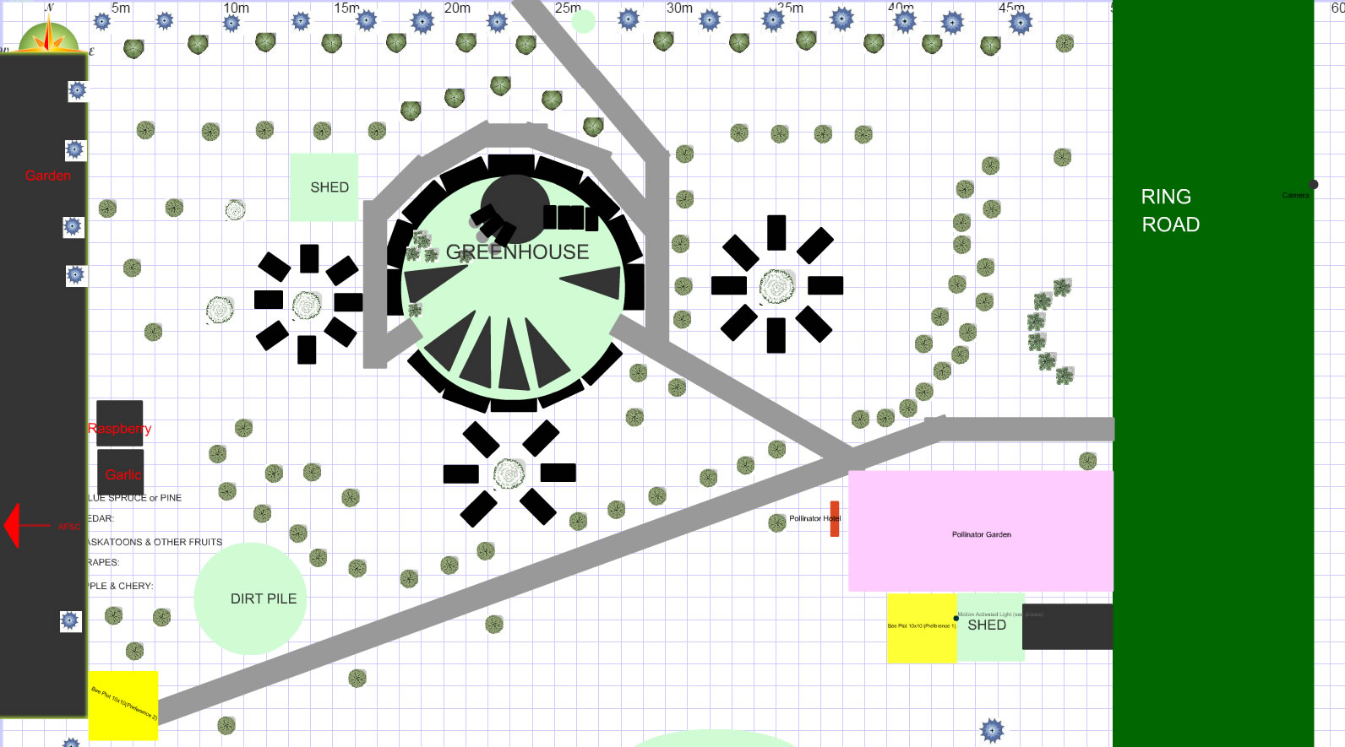
This is an exciting opportunity for our school to be involved in something great. Staff and students are enthusiastic and motivated to do whatever we can to make this project a huge success. We also extend a warm welcome to any community member who might have knowledge and experience with bees to come join our team. Let’s come together and support our students in a learning project that is real, meaningful, and highly important to our earth. The LCHS community is very excited about the possibilities that might arise from our Bee Wise Project. With the support of the community, we hope to produce enough honey to sell as a fundraiser to support our Dow community garden and build other agricultural opportunities.
Provide additional details about how to get involved. Parents, Lacombe citizens and interested stakeholders are invited to attend our weekly BEE WISE meetings on Wednesday after school (4 - 6pm) If you want more information please phone or email the EcoVision teacher advisor, Mr. Schultz (403-782-6615 ext 5205; steven.schultz@wolfcreek.ab.ca) or emailing our EcoVision students. (Avy Lamb - EcoVision Leader: lamb.a@wolfcreek.ab.ca). For additional information you can visit our website: www.lchsecovision.weebly.com.

